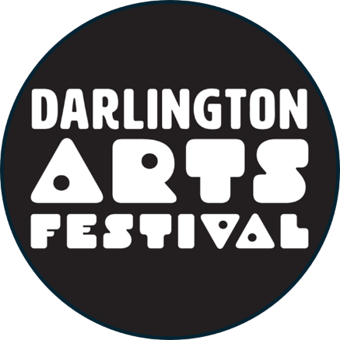

**2024 Darlington Arts Festival**

**Bump in and other information.**

Festival hours for 2024 are: Saturday November 2nd 2024 10.00 a.m. to 5.00 p.m.

Sunday November 3rd 2024 10.00 a.m. to 4.30 p.m.

Set up can be on Friday 1st November 2024 from 2.00 p.m. to 5.00 p.m. with all vehicles off the oval by 5.00 p.m. on Friday 1st November 2024

Or on Saturday 2nd from 7.00 a.m. to 9.00 a.m. All vehicles must be off the oval by 9.00 a.m. Saturday 2nd November.

Entry is via the gate at the NORTH WEST end of the Darlington Oval, with access to this gate from the service road off Pine Terrace adjacent to the Darlington Volunteer Bush Fire Brigade building.

Food vendors may be required to arrive in a strictly established time sequence in order to fit everybody in easily and comfortably. Late arrival may mean you won’t be able to access your allocated site with no alternative sites available.

There will be security patrols on the oval on Friday and Saturday night.

The contact details for Stall and Grounds are:

Ron Stuurstraat 0451 66 2917 Alex Hoschke 0439 976 672

Brendon Thompson 0427 250 566